**Platform vs Environment**

OS acts as the foundation for other application software, the term platform is used to represent operating systems, such as Linux platform and Windows platform. Each software platform supports its own application software, but isolated software performing an individual task such as a word processor or a web browser is not a platform.

The major usage of the term environment is to denote a certain type of generic configuration of computers. Such as networking environment, database environment or web services environment, which are computer software and hardware configurations operating on a larger scale. It can be used to express much simpler configurations too; for example, desktop environment, multimedia environment and gaming environment on a personal computer.

**What is the difference between Platform and Environment?**

* The term environment is used to describe collective configurations of computers, software or hardware at higher levels, while the platform is restricted to the foundation level structure.
* While the two terms share a similar intent, there is an important difference between them: “platform” implies a technology-centric view of the system while “environment” implies a people-centric view. A platform is something you build upon. An environment is *where you have experiences* i.e. **We exist within environments. They host our activities.**

What is Environments in DevOps/MLOps and Types of Environment Used:

A **software development environment (SDE)** is “a collection of hardware and software tools a system developer uses to build software systems.”

In general, there are four types of software development environments:

1. **Development Environment:**This is where application/system development tasks, such as designing, programming, debugging, etc., take place. It serves as a workspace for developers to perform programming, commit code, experiments, fix bugs, make mistakes etc…
2. **Test Environment:**As the name implies, this is where application testing is conducted to find and fix errors.
3. **Staging Environment:**Here, all the work done in the development environment is merged into the built system (often used to automate the process of software compilation) before it is moved into the production environment.
4. **Production Environment:**The last environment in software development, this is where new builds/updates are moved into production for end users.

Why should we have separate development, testing, and production environments?

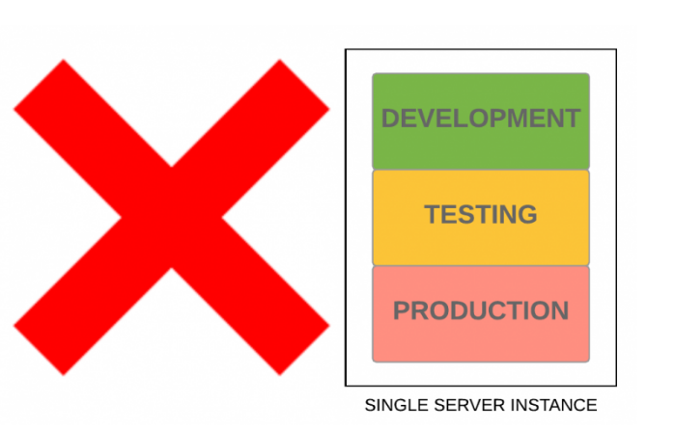

NOTE: Same Environment would mean using same Server, which is dangerous.

* The main reason is that you never want to mix testing and production environment because development involves a lot of debugging and testing. One incorrect program can spoil the server’s memory, CPU cores, Disk I/O and “hang” it.
* While administering quality assurance, unit tests, and stress testing, you need to make sure they are executed in a totally segregated environment. If something explodes in a development environment or in QA, it will adversely affect the production environment and thus live users and their mission-critical data! Having shared Server for dev, test and production mean shared resources between dev, test, and production./,./.
* We don’t want the business to grind to a halt because a new build has pushed to your servers it has started swapping on hard-drives and are consuming every core on the processor.

Reasons for having separate environments:

* To improve the SLA of application and provide better user experience to your users.
* To reduce the risks of production data getting into the wrong hands. It is very important when organizations deal with very sensitive and private data, like client information, ID, numbers, financial transactions and health information. Moreover, we want this for avoiding production data getting intermingled with test data.
* Write access to a production server is limited to specific system engineers.
* A production server hosts only live applications and finalize content. The unfinished and preliminary versions of applications and data should never be placed on this server, except possibly under highly controlled test conditions.